Isolate User Device

You will receive the transferred ticket from SD team in below form .Pick the ticket and check for the device name which needs to be Isolated ,Mostly we will get such tickets for the offboarding of users purpose .

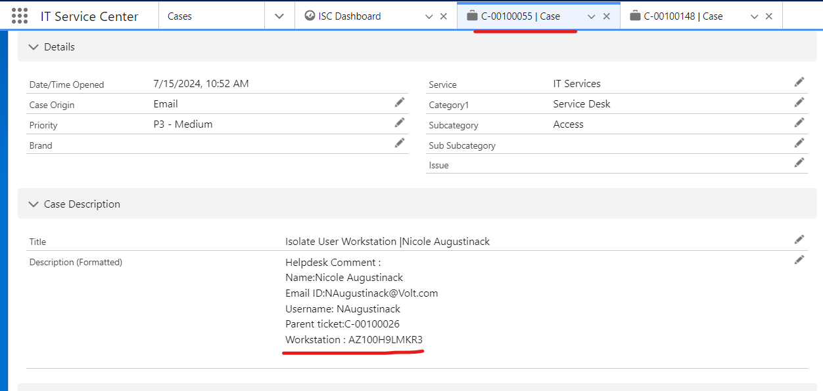
In next step search the device on Defender , In my case device name is AZ100H9LMKR3
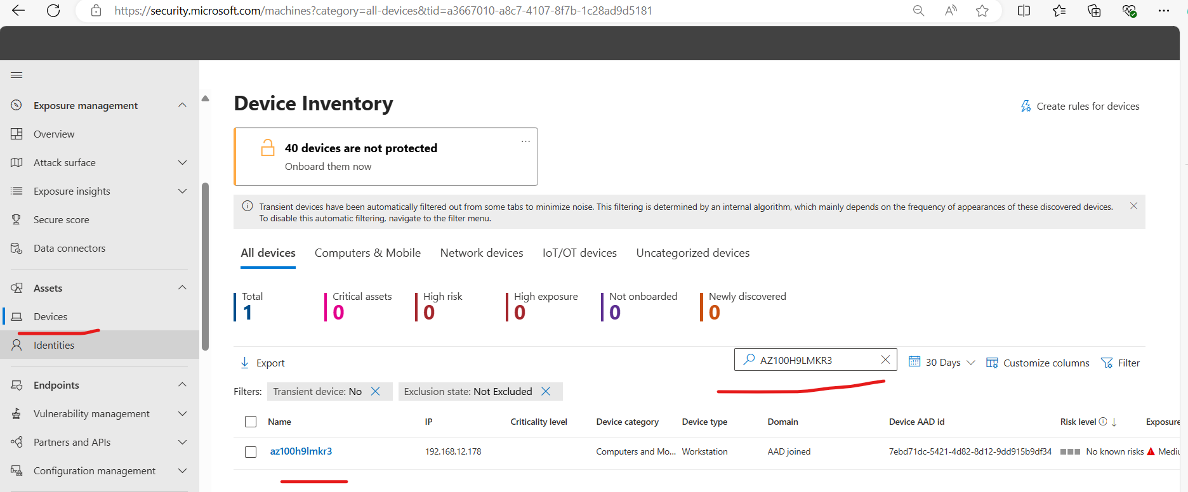

Click to 3 dots on right side top to get he device isolation option ,but before that cross check the device OS , to make sure if you are not isolating any server instead of user device .

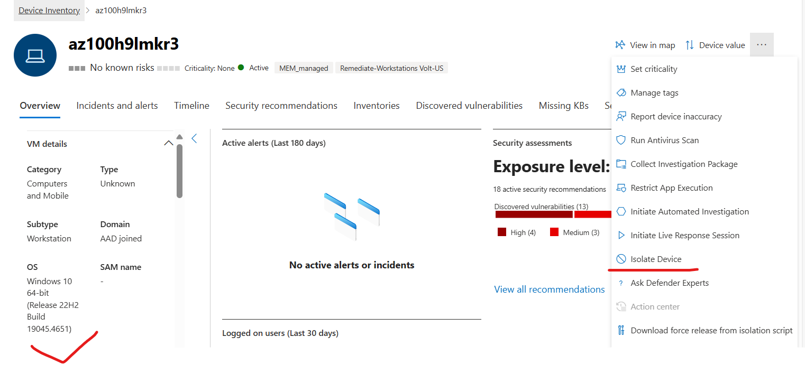

Click Isolate device and write the reason for isolation and click confirm.

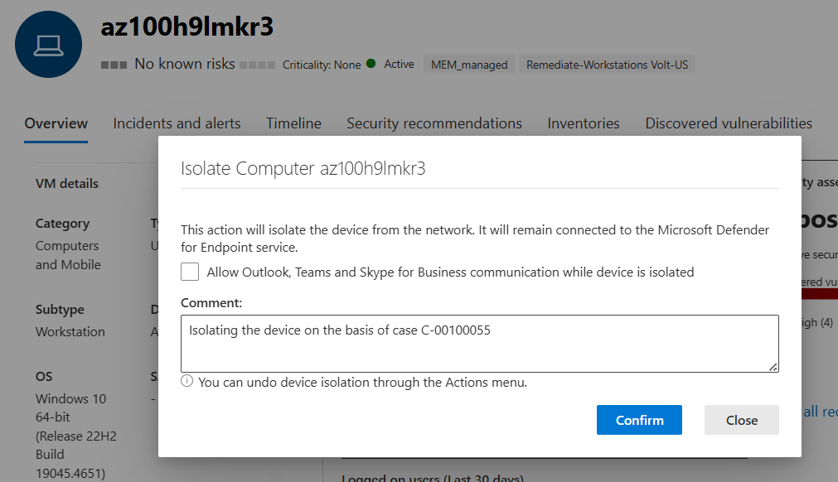

Note : For submitted actions to take effect, device must be connected to the network.

